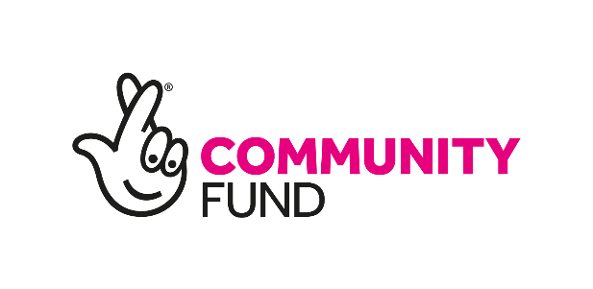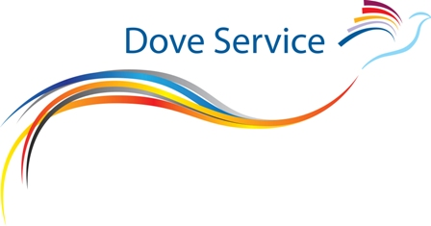**Qualified Project Counsellor/ Community Support Worker (Grief Facilitator) – Wirral region (Part Time)**

Job Reference Code: (TNL508QPC/GF)

**Grief Out Loud Project**

**Person Specification**

|  |  |
| --- | --- |
| **Factor** | **Essential (E) or Desirable (D)** |
| **Qualifications**  GCSEs (or equivalent) in English and Maths (Grades A*-C)  2 A Levels (or equivalent)  Training delivery qualified e.g. L3 AEL or equivalent  Qualified Counsellor (to diploma level 4 or above) | E  E  D  E |
| **Experience**  Experience of working with C&YP.  Experience of delivering training/workshops and group work to diverse audiences.  Experience of delivering interventions in localities, networking, and building relationships.  Experience in project co-ordination, and of lone working in localities/ communities/ C&YP settings.  Experience of delivering training and other interventions via video platforms  Knowledge & experience of developing & maintaining groups.  Experience of appropriate liaison, supporting and networking with other professionals.  Experience of delivering counselling & therapeutic support face-to-face, online and by telephone.  Minimum of 250 hours experience of counselling both C&YP & Adults | E  E  E  D  D  D  D  E  E |
| **Knowledge**  Excellent working knowledge of statutory initiatives, ethical practice, and legislation that impact on C&YP such as, Every Child Matters and the Children Act (2004) and Working together to Safeguard Children (2013) etc.  Knowledge of theory of bereavement & loss and its impact on C&YP.  Working knowledge of MS Word, Powerpoint, excel, Team and Zoom. | E  D  E |
| **Skills & Abilities**  Ability to produce Powerpoint presentations, workshops and develop training programmes suitable for audience needs and ability.  Ability to provide support & train Community Grief Champions who wish to participate in the project.  Ability to work within and adhere to Project outcomes, milestones and timescales.  Ability to work with C&YP to facilitate C&YP led advisory groups for consultation & service evaluation & develop promotional material relevant to the outcomes of the project.  Good administration skills including the ability to develop resources, and write reports accurately and on-time.  Experience of evidence based practice, assessment tools and evaluation. | E  E  E  D  D  E |
| **Personal Qualities**  Excellent communicator (verbal and written).  Good ambassador and able to promote TDS aims and objectives.  Professional attitude and conduct.  Flexible working to meet the needs of C&YP and their families, stakeholders and TDS.  Open to change and new challenges, adaptable, and prepared to explore new ways of working. | E  E  E  E  E |
| **Motivation**  Able to work on own initiative and to use time effectively. | E |
| **Team Working**  Good team player.  Able to identify & gather required statistics and to communicate these effectively to Management. | E  E |
| **Professional**  Individual membership of BACP or other professional body.  BACP individual accreditation (or equivalent).  Work within the BACP Ethical Framework of Good Practice (2010).  Personal Continuous Professional Development (CPD) | E  D  E  E |
| **Other:**  Clean Disclosure & Barring (DBS) check  Valid driving licence, own car and ability to travel. | E  E |

November 2023