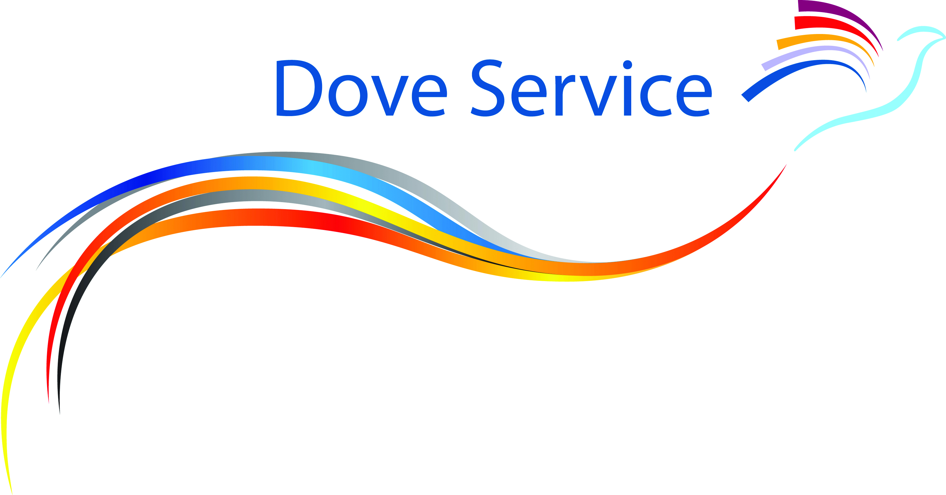


Qualified Counsellor (Part time)
Cheshire & Staffordshire
(Job Reference Code: TNL508C)

Person Specification

Factor | Essential (E) or Desirable (D)
Qualifications  Qualified Counsellor (to diploma level 4 or above)  Minimum of 250 hours experience of counselling adults and C&YP  GCSEs (or equivalent) in English and Maths (Grades A*-C)  2 A Levels (or equivalent) | E  E  E  E
Experience  Experience of working with C&YP  Experience of working with adults  Experience of delivering counselling & therapeutic support face-to-face, online and by telephone.  Experience of appropriate liaison and networking with other professionals. | E  E  E  D
Knowledge  Excellent working knowledge of statutory initiatives, ethical practice, and legislation that impact on C&YP such as, Every Child Matters and the Children Act (2004) and Working together to Safeguard Children (2015) etc.  Excellent working knowledge of Safeguarding Vulnerable adults and Safeguarding Children & Young people  Knowledge of theory of bereavement & loss and its impact on C&YP/adults.  Working knowledge of MS Word, Powerpoint & Excel. | E  E  D  E
Skills & Abilities  Experience of evidence based practice, assessment tools and evaluation.  Ability to work within and adhere to Project outcomes, milestones and timescales.  Ability to produce information to support report writing including client stories and case studies. | E  E  E
Personal Qualities  Excellent communicator (verbal and written).  Good ambassador and able to promote TDS aims and objectives.  Professional attitude and conduct.  Flexible working to meet the needs of C&YP and their families, stakeholders and TDS.  Open to change and new challenges, adaptable, and prepared to explore new ways of working. | E  E  E  E  D
Motivation  Able to work on own initiative and to use time effectively. | E
Team Working  Good team player.  Able to identify & gather required statistics and to communicate these effectively to Management. | E  E
Professional  Individual membership of BACP or other professional body.  BACP individual accreditation (or equivalent).  Work within the BACP Ethical Framework for the Counselling Professions (2018).  Personal Continuous Professional Development (CPD) | E  D  E  E
Other:  Clean Disclosure & Barring (DBS) check  Valid driving licence, own car and ability to travel. | E  E
November 2023

